  - Process Description

Procedure for Providing Traceability of Calibration for AOD retrievals within ACTRIS
Contents
2 Introduction 2
3 Travelling reference 2
3.1 PFR Operation Requirements 2
4 Traceability of DUT Calibration 2
4.1 Quality assurance of PFR data 2
4.2 AOD retrieval 3
4.3 Uncertainty Budget 5
4.3.1 Calibration & Stability 5
4.3.2 AOD Combined uncertainty. 5
4.4 Synchronization 7
5 Comparison Protocol 7
5.1 Statistical Analysis 7
6 Protocol of issuing Traceability of Calibration Certificate 8
7 Document Revisions 9
Authors 9
Reference Documents 9

Introduction
The aerosol optical depth (AOD) traceability of the Precision Filter Radiometer Reference Group of the World Optical depth Research and Calibration Center of the World radiation Center (WRC-WORCC) maintained and operated at PMOD, is represented by the traveling standard PFR (PFR-TS). This document describes the procedure of providing traceability to WMO AOD-reference of the calibration of the AERONET-Europe master instruments. For that purpose, traveling standards, are operated at the three calibration centers of ACTRIS and AERONET-Europe OHP (University of Lille), Izaña (AEMET) and Valladolid (UVa) and a comparison of Aerosol Optical Depth (AOD) measurements is performed. The calibration traceability certificate is based on an outdoor comparison of the AOD values at the wavelengths of a master AERONET-EU instrument to the PFR travelling reference.

Travelling reference
The travelling reference is a PFR filter radiometer which measures the direct solar irradiance at nominal centroid wavelengths 368 nm, 412 nm, 500nm and 862 nm. The instrument is temperature stabilized to minimize any temperature dependencies in the responsivity of the 4 sensors. The PFRs have an average degradation factor of less than 0.2% per year mainly due to the short exposure to the sun (0.2s /measurement ) and the fact that the interference filters are in a shield nitrogen environment. The solar trackers used for the PFRs have a tracing accuracy of better than 0.01º in active sun-tracking mode.

PFR Operation Requirements
The data of the Cimel instrument are downloaded in daily bases from the AERONET site (lev15, tot15) and a preliminary comparison between the instrument is done.

Traceability of DUT Calibration
The performance of the Device Under Test (DUT) , master instrument of AERONET-EU, is validated by an outdoor comparison of the AOD values at the wavelengths of DUT to the PFR travelling reference. The interpolation of AOD is performed using the Ångström exponent retrieved from the four PFR wavelengths.

Quality assurance of PFR data
The basic procedure of the quality assurance of WORCC AOD retrievals from PFR direct Sun measurements is described in Kazadzis S., et al. (2018). Furthermore, to reduce the uncertainty of the dataset and the comparison results, the following criteria are applied automatically and/or during visual inspection:
- Atmospheric variability less than 0.5%/min
- Cloud screening
- Alignment to the sun better than 10 arcmin
- Cleanliness uncertainty better than 0.01%

AOD retrieval
The spectral AOD is calculated using the Beer-Lambert law as,
$$τ_{aod}={\left[\log\left(\frac{Ic}{Io}\right)+\left(τ_{ray}m_{ray}+ \sum_{i}{τ_{i}}m_{i}\right)\right]}/m$$
Where $I_{c}^{}=I∙\left(1-I_{Cleaning}^{rel}-I_{FOV_{strl}}^{rel}- I_{Clouds}^{rel}\right)$. The wavelength term has been omitted for simplicity.
Expanded to explicitly mention all main gases, yields the measurement equation for AOD,

$τ_{aod}={\left[\log\left(I\right)-\log\left(I_{0}\right)+\left({XS}_{ray}m_{ray}P/{P_{0}}+τ_{NO2}m_{NO2}+τ_{O3}m_{O3}\right)\right]}/m$ (Eq.1)
Where $τ_{TraceGas}={TC}_{TraceGas} {XS}_{TraceGas}$
Where the wavelength term has been omitted for simplicity.
- $Ic$ is the measured direct solar irradiance (signal or calibrated) corrected for the contributions of cleaning efficiency $I_{Cleaning}^{rel}$, straylight in the FOV of the instrument $I_{FOV_{strl}}^{rel}$ and attenuation due to clouds $I_{Clouds}^{rel}$.
- I₀ is the solar irradiance at the top of the atmosphere.
- τ_{ray} is the optical depth of Rayleigh scattering.
- m_{ray} is the airmass for Rayleigh scattering.
- τ_{NO2} is the optical depth of nitrogen dioxide.
- m_{NO2} is the airmass for nitrogen dioxide.
- τ_{O3} is the ozone optical depth.
- m_{O3} is the ozone airmass.
- m is the aerosol airmass
- P is the pressure at the site
- P0 is the pressure at 1 atm, 1013.25 mbar.
- ${TC}_{TraceGas}$ total column of trace gas
- ${XS}_{TraceGas}$ trace gas absorption cross-section weighted by the normalized measured or assumed responsivity of the filter with centroid wavelength λ.
The AOD retrieval at the PFR wavelengths is done using the calibration ($I_{0}$) against the PFR-Triad, the atmospheric pressure is measured by a Setra barometer installed in the data acquisition system of the PFR and total column of ozone provided by the OMI overpass (EOS Aura OMI OMTO3 (v8.5, Collection 3)). The NO₂ is not accounted for in the standard WORCC retrieval, however, to eliminate differences in AOD due to NO₂, the climatological data provided in AERONET version 1.5, is used. The extra/ interpolation to the AOD values at the centroid wavelengths of the Cimel interference filters, is done using the Angstrom exponent (a) retrieved from all four PFR wavelengths according to the equation 2.

$τ_{aod}\left(λ_{Cimel}\right)=τ_{aod}\left(λ_{PFR}\right){\left(\frac{λ_{Cimel}}{λ_{PFR}}\right)}^{-AE}$ (Eq.2)
Where:
The extra/interpolation method uncertainty depends on wavelength, AE and AOD. The uncertainty budget for this component is calculated for the combined uncertainty of the calibration of each PFR-TS using a Monte Carlo approach. An example of the calculated AOD differences (AOD extra/interpolated - AOD ) and their uncertainties based on the Monte Carlo analysis for a combined irradiance uncertainty of the PFR ~ 0.3% and aerosol load of 0.01 at 500nm and AE=2.1 is shown in Figure 1. An example of the same uncertainties in the PFR atmospheric transmittance , AOD at 500 nm 0.01, and AE ranging from 0.8 to 2.5 is presented in Figure 2. The uncertainty increases with decreasing AE, with exception the 1020 nm.
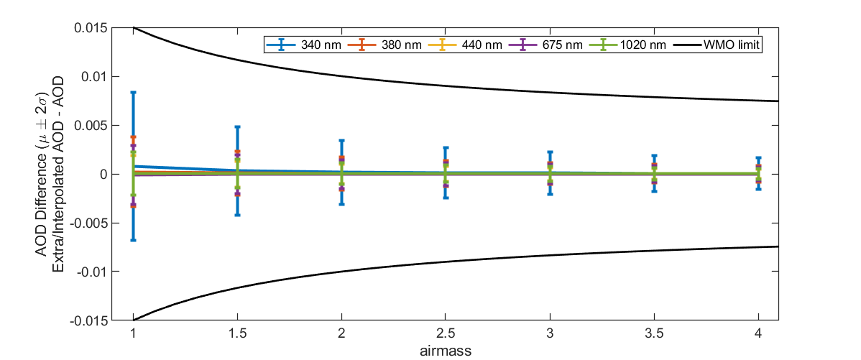
Figure 1: Example of AOD differences at 340nm,380 nm, 440 nm, 675 nm and 1020 nm and Monte Carlo uncertainty of the true and extra/interpolated AOD from the PFR wavelengths 368 nm, 412 nm, 500 nm and 862 nm with a combined expanded relative irradiance uncertainty of 0.32%, 0.32% , 0.30% 0.24% respectively (AE=2.1 and AOD at 500 nm = 0.01) plotted against the airmass. The WMO maximum uncertainty of AOD differences is indicated (black line).

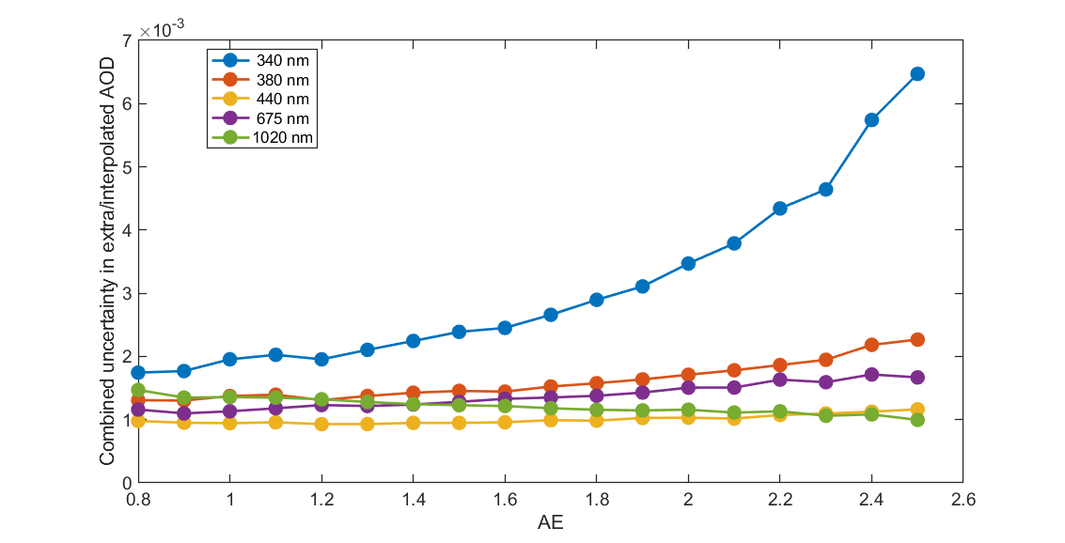
Figure 2: Example of combined uncertainty introduced to the extra/interpolated AOD to 340nm,380 nm, 440 nm, 675 nm and 1020 nm, due to the extrapolation method and uncertainties in the measured atmospheric transmittance by the PFR at 368 nm, 412 nm, 500 nm and 862 nm with a combined expanded relative irradiance uncertainty of 0.32%, 0.32% , 0.30% 0.24% respectively (AOD at 500 nm = 0.01).

Uncertainty Budget

Calibration & Stability
The calibration uncertainty of the PFR-TS is calculated during the calibration procedure against the PFR-Triad. For the case of Izaña although the onsite Langley calibration is used for the AOD retrieval the uncertainty of the last PFR-Triad calibration is used. The uncertainty of the stability of the PFR-TS is estimated as the difference between the last 2 calibration while for the Langley sites for the uncertainty of the Langley calibration. A detailed description of the uncertainty budget of the calibration procedure against the PFR-Triad can be found in QM-PD-WORCC-0004.

AOD Combined uncertainty.
The combined variance of the AOD is derived the sum of the squares of the partial derivatives of equation 1 with respect to each component $x_{i}$ multiplied by the square uncertainty of this component $u_{xi}$.
$$U_{AOD}=2\sqrt{\sum_{i}{{\left(\left(\frac{∂τ_{aod}}{∂x_{i}}\right)∙u_{xi}\right)}^{2}}}$$
In Table 1 the partial derivatives (sensitivity coefficients ) are presented categorized in uncertainties of measured irradiance, optical path, trace gases concentration and Rayleigh scattering, wavelength uncertainty. Detailed description of the uncertainty of each component can be found in QM-PD-WORCC-0006.

Table 1: Partial derivatives (sensitivity coefficients ) are presented categorized in uncertainties of measured irradiance, optical path, trace gases concentration and Rayleigh scattering, wavelength uncertainty.
Irradiance | Optical path - Airmass | Trace Gases Concentration/ Total column | Wavelength
$$\frac{ϑτ_{aod}}{ϑI}=\frac{1}{I}∙\frac{1}{m}$$ | $$\frac{ϑτ_{aod}}{ϑm_{ray}}=\frac{τ_{ray}}{m}=\frac{{XS}_{ray}}{m} \frac{P}{P_{0}}$$ | $$\frac{ϑτ_{aod}}{ϑτ_{ray}}=\frac{m_{ray}}{m}$$  Where ${ϑτ}_{ray}= \frac{{XS}_{ray}}{P_{0}}ϑP$  Or  $$\frac{ϑτ_{aod}}{ϑP}=\frac{{{XS}_{ray}m}_{ray}}{m}\frac{1}{P_{0}}$$ | $$\frac{ϑτ_{ray}}{ϑ{XS}_{ray}}=\frac{m_{ray}}{m}\frac{P}{P_{0}}$$
$$\frac{ϑτ_{aod}}{ϑI_{Cleaning}^{rel}}=\frac{1}{I}∙\frac{1}{m}$$ | $$\frac{ϑτ_{aod}}{ϑm_{O3}}=\frac{τ_{O3}}{m}$$ | $$\frac{ϑτ_{aod}}{ϑτ_{O3}}=\frac{m_{O3}}{m}$$ | $$\frac{ϑτ_{O3}}{ϑ{XS}_{O3}}=\frac{m_{O3}}{m}{TC}_{O3}$$
$$\frac{ϑτ_{aod}}{ϑI_{FOV_{strl}}^{rel}}=\frac{1}{I}∙\frac{1}{m}$$ | $$\frac{ϑτ_{aod}}{ϑm_{NO2}}=\frac{τ_{NO2}}{m}$$ | $$\frac{ϑτ_{aod}}{ϑτ_{NO2}}=\frac{m_{NO2}}{m}$$ | $$\frac{ϑτ_{NO2}}{ϑ{XS}_{N02}}=\frac{m_{NO2}}{m}{TC}_{NO2}$$
$$\frac{ϑτ_{aod}}{ϑI_{Clouds}^{rel}}=\frac{1}{I}∙\frac{1}{m}$$ | …. | …. | …
$$\frac{ϑτ_{aod}}{ϑI_{0}}=\frac{1}{I_{0}}∙\frac{1}{m}$$ | $$\frac{ϑτ_{aod}}{ϑm_{}}=\frac{τ_{aod}}{m}$$

The main sources of uncertainty in the PFR-TS AOD retrievals and their values estimated by literature, analysis of long-term data or statistics are presented in Table 2.

Table 2: The main sources of uncertainty in the PFR-TS AOD retrievals and their values
Source of uncertainty | Uncertainty (k=2)
Pressure | 3 mBar
Ozone (${TC}_{O3}$) | 5%
NO₂ AERONET climatology (AERONET data lev15) ${TC}_{NO2}$ | 0% (chancels out in the AOD differences)
Wavelength centroid | 0.2 nm
PFR-TS Calibration | As defined in the certificate of the PFR-TS
PFR-TS Stability | See 3.5.1 Calibration & Stability
Cleaning efficiency | 0.01%
FOV uncertainty with respect to alignment (<±10 arcmin) | 0.05%
FOV straylight | 0
Measured direct sun irradiance | standard deviation of 10 sequential measurements (x2)

Synchronization
The synchronization method is based on selecting the nearest measurement of DUT to the PFR-TS within a maximum difference of 30 sec and airmasses higher than 4.5. To account for the different measurements protocol atmospheric conditions with a variability less than 0.5 %/min compared to a clear Sun condition are selected.

Comparison Protocol
The data of the Cimel instrument are downloaded in daily bases from the AERONET site (lev15, tot15) and a preliminary comparison between the instrument is done. Periodically the PFR-TS data are quality assured and data with uncertainty less than 0.012 in AOD are used for the comparison of DUT.

Statistical Analysis
The selected synchronized PFR -TS AOD at AOD data at the wavelength of the DUT are subtracted from the DUT AOD. A control of differences with respect of errors in the quality control of both PFR-TS and DUT is applied, excluding extreme values. Days with more than 10 common measurements are selected. The atmospheric conditions filter with respect the aerosol load and uncertainty of extra\interpolation is applied on the differences :
$$0.9≤AE≤2.2 and AOD(500 nm )<0.5$$

The AOD difference distribution is simulated by an appropriate multi-Gaussian function, the order depends on the amount of data, and it ranges from 3 to 8. The purpose of the simulation is to identify and quantify possible deviation from an expected normal distribution where the median is equivalent to the peak of the distribution. Significant departures from the normal distribution in any of the wavelength would lead in splitting the comparison in period and providing multiple certificates.

The median, percentile at confidence levels 2.3 ($P_{L}$) and 97.7 ($P_{U}$) of the AOD difference distribution are calculated. For each AOD difference bin $ΔAOD$the uncertainty of PFR-TS AOD is calculated form the mean uncertainty of the bin$U_{AOD}^{i}$and the standard deviation of $U_{AOD}^{i}$($σ_{U_{AOD}^{i}}$) based on:
$U_{AOD-PFR}(Δ{AOD}_{i} )=\sqrt{ {\left(U_{AOD}^{i}\right)}^{2}+{\left(2σ_{U_{AOD}^{i}}\right)}^{2}}$

The mean$U_{AOD-PFR}(Δ{AOD}_{i} )$ of the median ± 2 bins is the combined expanded uncertainty of the reference ($U_{R}$) AOD stated in the certificate.

The traceability certificate uncertainty$U$is calculated by:
$U=\sqrt{ {\left(U_{R}\right)}^{2}+{\left({\left(P_{U}-P_{L}\right)}/2\right)}^{2}}$

A certificate example along with explanation is given in

Protocol of issuing Traceability of Calibration Certificate
The certificate gives traceability to the calibration of the DUT device for the whole period it acts as a reference instrument. Within a month of the exchange of the DUT, and if a more than 15 day of low uncertainty data have been collected, the final comparison is done, the certificate is issued and delivered electronically to the PI of the calibration site. In case that the DUT device is operated more than 3 months, and the above criteria are fulfilled then a certificate is issued for that period.

Document Revisions
Version | Release Date | Approved By | Modified on | Created/  Edited by | Changes
1.0 |  |  | 20.03.2023 | nk | created

Note: Versioning a draft document: 0.x
Versioning of a shared document: 1.x
Version increment (x) for a significant change: x.1
Version increment (x) for a minor change: 1.x

Authors
Natalia Kouremeti (nk), Stelios Kazadzis (sk), Julian Gröbner (jg).

Reference Documents
1. Kazadzis, S., Kouremeti, N., Nyeki, S., et al. (2018) The World Optical Depth Research and Calibration Center (WORCC) quality assurance and quality control of GAW-PFR AOD measurements 10.5194/gi-7-39-2018 https://gi.copernicus.org/articles/7/39/2018/
2. QM-PD-WORCC-0004: PFR&FR_Calibration.docx
3. QM-PD-WORCC-0006: AOD_uncertainty.docx

